Concepts (10-15)
- Creating Church of England
- Search for male heir
- Multiple wives and children
- Beauty standards
- Monarch in England 1400-1500
- Control of a monarch-death
- Children of Henry VIII
- Artistic- makes music and wrote his own book (defender of the faith)
- Makes his own cures
- Daughter was Queen Elizabeth
- Henry’s older brother died, leaving him the next in line for the throne at the age of ten years old.
- Henry’s father originally envisioned Arthur being king and Henry as a high ranking church official
- Inherited a peaceful kingdom after his father ended the Wars of the Roses
IMPORTANT PEOPLE (3-5)
- Henry VII
- Queen elizabeth
- All his wives
IMPORTANT TERMS (3-5)
- Anglican Church
  - The Church of England and the churches in other nations that are in complete agreement with it as to doctrine and discipline and are in communion with the Archbishop of Canterbury. Also called Anglican Communion.
- Protestantism vs Catholicism
  - Protestantism-adherence to the forms of Christian doctrine that are generally regarded as Protestant rather than Catholic or Eastern Orthodox.
  - Catholicism-adherence to the forms of Christian doctrine and practice which are generally regarded as Catholic rather than Protestant or Eastern Orthodox.
- Constitutional monarchy
  - A form of government where the king's right to make law is acknowledged and supported formally by a legislative body, such as the English Parliament, and where effective rule is shared among the several branches of the government.
IMPORTANT STATEMENTS (3-5)
- Henry’s early life/interests
  - How he rose to power
  - Artistic/Facts About him
  - Monarch of England
- Henry's wives
  - Male heir
  - Church of england
  - Multiple kids (don’t go into specifics)
- Henry’s legacy
  - Elizabeth & kids
  - Impact
  - Beauty standards
  - Controlled monarchy/death

Abbie: June 28, 1491, one of the most infamous monarchs of all time, Henry Tudor, better known as Henry the 8th, was born to King Henry the 7th of England and his wife, Elizabeth York. Henry was the second child of four, having his older brother Arthur, and his two younger sisters Margaret and Mary. While Arthur was expected to take the throne following the death of their father, Arthur unexpectedly passed at the age of 15, leaving a ten year old Henry the next in line to the English throne. Henry’s father had long believed that Arthur would be king and Henry a high ranking church official, but as fate would have it, Henry was crowned King of England June 24, 1509 at the age of 18 years old. A charismatic and intelligent young man, Henry was fascinated by the arts and music, writing some of his own pieces. Besides the arts he was extremely into athletics, hosting countless jousting tournaments and banquets to go along with them. While many viewed him to be a good mannered man, his court learned to obey his every rule without question, and with good reason. Two days following Henry’s coronation he arrested two of his father’s ministers and swiftly had them executed. From there Henry began to continue his climb of power and greed, with his lust for power and success leading him down a long path of women and destruction in the search for a male heir.

Catherine of Aragon: Catherine of Aragon was King henry the 6th’s first wife and the longest of all of his marriages. She was the youngest surviving child of the “catholic kings of spain.Catherine was betrothed as an infant to marry king Henry’s older brother, arthur, but he passed away before she could. Henry then took his brothers placed and waited until her father passed away so that he could marry Catherine. They ended up having 6 children but only one survived, a daughter called mary. Henry however wasn’t filled with joy but with frustration because he only desired a son. As years passed on, he fell in love with another woman named Anne Boleyn and wanted an annulment with Catherine which she wouldn’t accept. He was denied by the church of the annulment so he decided to declare himself as the head of the new english church. He completed his annulment and banished catherine from court. She died a few years later broken hearted but still defiant.

Anne Boleyn: Anne Boleyn was King henry’s second wife. She was the daughter of an ambitious knight and niece of the duke of norfolk. She was an accomplished musician, singer, and dancer. Anne caught King henry’s not for her beauty, due to a large mole on the side of her neck and an extra finger on her left hand, but for her wit and style. Henry wanted her as his mistress but anne’s sister mary was already the king’s mistress. She was seriously involved with Henry percy, the son and heir of the earl of northumberland. King henry ordered his minister, cardinal thomas wolsey to end their romance and made percy unhappily mary the earl of shrewsbury's daughter. Anne boleyn eventually married henry after his annulment with Catherine. She unfortunately however couldn't give henry the son he wanted but gave birth to Elizabeth instead. Frustrated once more he ordered her to be executed on the false accusation of witchcraft, incest and adultery.

Bella: Jane Seymour: His third wife, whom he married 24 hours after executing Anne Boleyn, Jane Seymour was the only one of his six wives to produce a male heir. While not the prettiest of his wives, she was one of the most prominent wives, due to her production of a male heir and her being crowned queen of England. Sadly her reign didn’t last long though, Jane passed away two weeks after giving birth, some believe due to food poisoning. Henry decided to give her a funeral worthy of a queen, with her being the only one of his six wives to be buried alongside him.

Bella: Anne of Cleves: Following the death of Jane, Henry married his fourth wife, Anne of Cleves. Their marriage was a political arrangement, and it didn’t last long at all largely due to the fact that he was not attracted to her in the slightest. Many times it was said that he wanted to end the marriage and divorce her, but he didn’t feel he was able to do so because of his feelings he had to stay true to his political ties. Eventually though Henry was fed up with the marriage and requested an annulment, which Anne agreed to. She spent the rest of her life living an independent lifestyle that most women were not capable of, being a frequent honored guest in Henry’s court.

Kathryn Howard: Catherine Howard came to court when she was 19 as a lady in waiting for Anne of Cleves. The king took interest in her, and her uncle was thought to have encouraged her to respond to his advances in order to increase his influence. Sixteen days after Anne of Cleves died of cancer, Henry married Catherine. She lifted his spirits and he gave her many lavish gifts and called her his “rose without a thorn” as well as “the very jewel of womanhood”. Although Catherine was married, she was very promiscuous. She had affairs to men closer to her own age since she was 19 and the king was 49. She appointed one of the men whom she had an affair with as her personal secretary. Rumours arose of her infidelity and evidence was gathered that she was promiscuous before her marriage and may have had affairs. She was later executed on Tower Green on Feb 13, 1542. Her reign as queen lasted for 18 months, she was laid to rest next to her cousin, Henry’s late wife, Anne Boleyn.

Katherine Parr: Katherine Parr was the last wife of King Henry VIII. She was named after his first wife Catherine of Aragon by her mother. Prior to marrying the king, she was married to Edward Burrough and John Neville who both died of illness. She was a stepmother to kids from Neville’s previous marriage. Although she later fell in love with Thomas Seymour, brother of the late Queen Jane Seymour, she felt it was her duty to accept the King’s hand in marriage when offered. Katherine was interested in the reformed faith making her an enemy of Henry’s court. A plot rose against her in 1546 trying to out her for heresy. Henry chastised her for trying to lecture him about religious, which she responded to by claiming it was so she could be instructed by him and take his mind of other troubles. This ended up keeping her safe. After Henry died, she secretly married Thomas Seymour. She had another daughter named Mary and died from a fever resulting from childbirth.

Finding an heir was extremely important due the fact that the pope was threatening excommunication. Edward VI reigned from 1547-1553 and reigned when he was 9 years old. He was the eagerly waited son heir of Henry viii and Jane Seymour. His reign did not last long because he died at age 16.
Mary Tudor was the first female heir Henry Viii had. Her reigned as queen lasted from 1553-1558. She was Catholic as queen and tried to return england to catholic faith. She was nicknamed “Bloody mary” because she was known for killed nearly 300 people during her reign until her death.
Elizabeth Tudor was the final heir of henry viii, and she reigned the longest of the Tudor family from 1558 - 1603. She is famous for being the 'virgin queen' as she never married. Elizabeth set England back on the Protestant path after Mary’s attempt to return the country to Catholicism. She reigned until her death in 1603.
Religion was big part of the time of reign under Henry VIII. He was very much devoted to the Catholic church and protected it against Protestants. However, he decided to make the king the head of the church rather than the pope when the Pope refused to grant a divorce from Catherine of Aragon. This event marked the start of centuries of religious conflict in Britain. After the death of Henry VIII in 1547, England became a protestant nation under his son Edward VI, back to catholic under the reign of Mary I, and then back to Protestant under Elizabeth I.
Although Henry viii was known as a beautiful king, it was his heir Elizabeth Tudor who set the beauty standards for the time period. The ideal woman had porcelain white skin and red lips. Hair blond or fair and light colored eyes. Makeup was a symbol of status.
He died on January 28, 1547 at 56 years of age, which was above the life expectancy at the time which was 50 years. He had reigned for 38 years.

King Henry VIII
Catherine Parr 1543-1546 | - Was named after queen Catherine of Aragon  - First marriage was to Edward Borough (deceased)  - Second marriage was to John Neville  - Third Baron Latimer of Snape Castle  - Step mother to his kids from previous marriage  - 19 years apart  - Was taken hostage with stepchildren at the castle  - Latimer eventually secured their freedom  - Latimer died  - Fell in love with Thomas Seymour (brother of late Queen Jane Seymour)  - Felt it was her duty to accept the King’s hand in marriage  - Interested in reformed faith  - Enemy of conservatives of KHVIII’s court  - Plot against her in 1546  - Had banned books which was heresy  - Warrant issued for queen’s arrest; warrant accidentally dropped and someone told Queen about it  - KHVIII chastised her for trying to instruct him on religious views but she said she was only arguing with him so she could be instructed with him and to take his mind off of other troubles (he forgave her and she was safe)  - Was close with her stepchildren  - Patron of the arts and music  - “Prayers or Meditations” became the first work published by an English queen under her own name  - After HVIII died, secretly married Thomas Seymour  - Became a scandal  - Became pregnant for the first time in June 1548  - Daughter Mary  - Fell ill with puerperal fever (died September 5)
Catherine Howard 1540-1541 | - Married 16 days after Anne died  - Anne Boleyn’s cousin  - Henry was 49 and Kathryn was no more than 19  - Henry said she was his “rose without a thorn” and “the very jewel of womanhood”  - Was promiscuous  - Had affairs with other dudes closer to her own age  - Appointed one of them as her personal secretary  - Infidelity rumours  - Evidence gathered that she was promiscuous before marriage and may have had affairs  - Executed on tower green on Feb 13, 1542  - Reign as queen lasted for 18 months
Anne of Cleves 1540-1540 | -4th wife  -Henry claimed he couldn’t fulfill his husbandly duties due to Anne’s appearance  -agreed to the annulment  -very brief marriage  -independent lifestyle different from most women, visited Henry’s court frequently as an honored guest  -ill suited for the royal lifestyle  -”Flanders Mare”
Jane Seymour 1536-1537 | -3rd wife  -was the only wife to provide Henry with a son/male heir  -not extremely pretty  -married to Henry 24 hours after Anne Boleyn’s execution  -only one of Henry’s wives to die as queen  -received a royal funeral  -only one of Henry’s six wives to be buried with him  -formed strong bond with Henry’s daughter Mary Tudor  -died two weeks after giving birth
Anne Boleyn 1533-1536 | - Daughter of an ambitious knight and niece of the duke of Norfolk.  - Was an accomplished musician, singer, and dancer.  - Anne as plain, sallow, and possessing two distinct flaws – a large mole on the side of her neck and an extra finger on her left hand.  - Wit and style were her greatest charms  - Service of Katharine of aragon but caught eye of Henry VII.  - Wanted her as his mistress  - Anne boleyn's sister mary was the king’s mistress  - Anne was also seriously involved with Henry Percy, the son and heir of the earl of Northumberland; there were rumors of an engagement and declarations of true love. The king ordered his great minister, Cardinal Thomas Wolsey, to end the match. Wolsey did so, thus ensuring Percy’s unhappy marriage to the earl of Shrewsbury’s daughter and Anne’s great enmity.  - Waited 7 years for him to get an annulment.  - Couldn’t give Henry the son he wanted and had Elizabeth instead.  - She was executed on patently false charges of witchcraft, incest and adultery on 19 May 1536.
Catherine of Aragon 1509-1533 | - First wife of King Henry and the longest.  - Catherine was supposed to marry King Henry’s older brother, arthur, but he passed away. So Henry had to wait until her father passed away until he could marry her.  - At the age of three, she was betrothed to his infant son, Prince Arthur.  - The youngest surviving child of the ‘Catholic Kings’ of Spain, Catharine was born on 16 December 1485, the same year that Henry VII established the Tudor dynasty.  - They had only one living child out of 6, a daughter called mary, he wanted a son  - Henry fell in love with another woman (Anne Boleyn) and wanted an annulment but she fought it.  - But the king would not be denied and when the Catholic church would not grant the annulment, he declared himself head of a new English church. Katharine was banished from court and died on 7 January 1536, broken-hearted but still defiant.  - Henry asked the Catholic Church to invalidate his marriage because Catherine had been married to his brother. However, Catherine refused to go along with Henry's plan, swearing that her marriage to Arthur had remained unconsummated.

http://tudorhistory.org/howard/
https://englishhistory.net/tudor/monarchs/catherine-howard/
http://www.biography.com/people/henry-viii-9335322
https://englishhistory.net/tudor/monarchs/anne-of-cleves/

Images:

Part One:
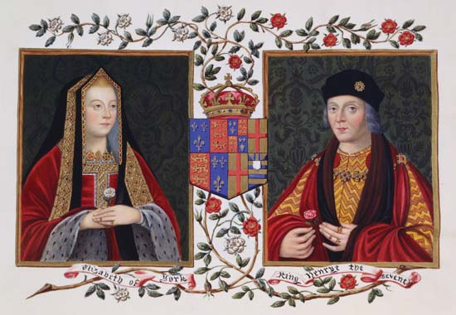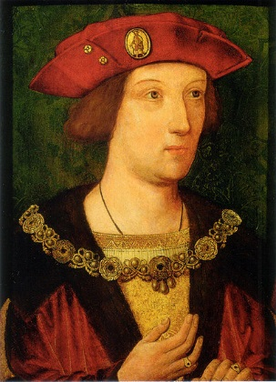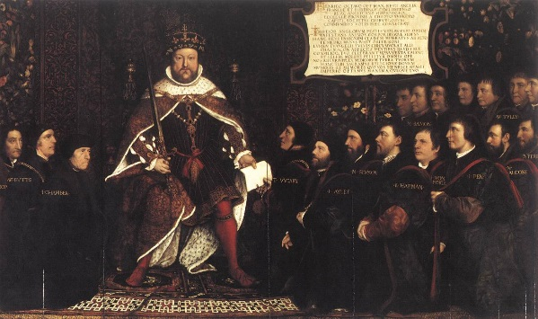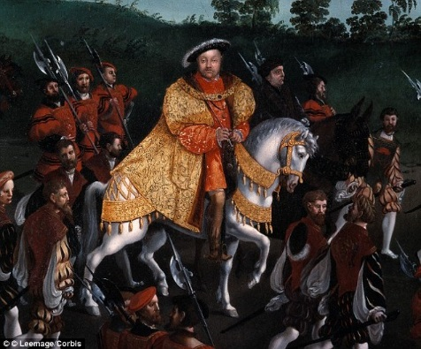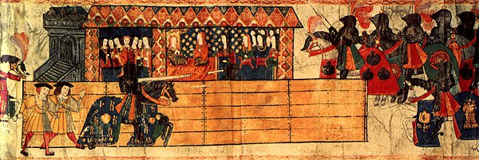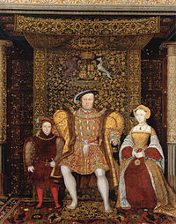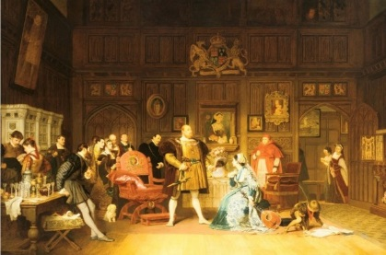

Part Two:
Katherine of Aragon: 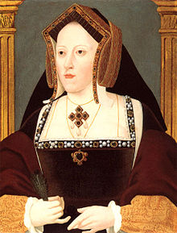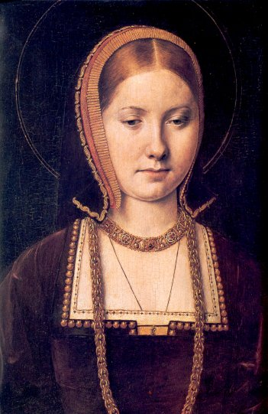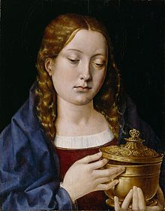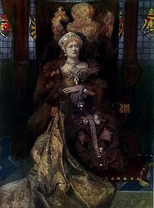

Anne Boleyn: 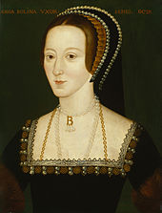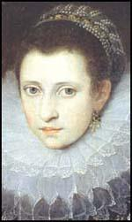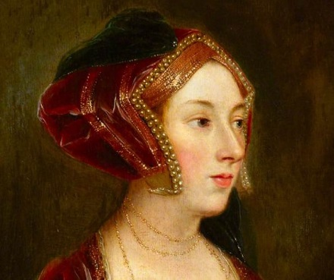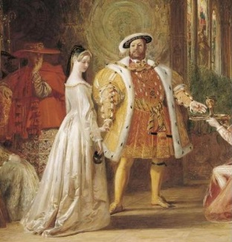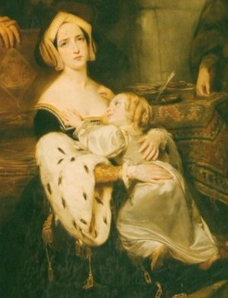

Jane Seymour: 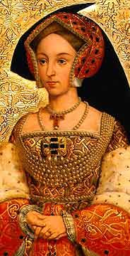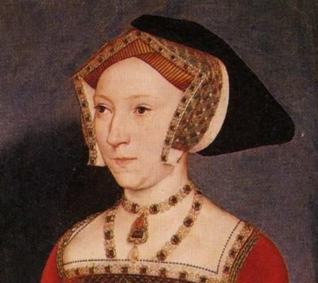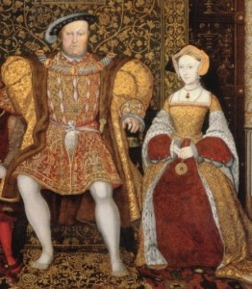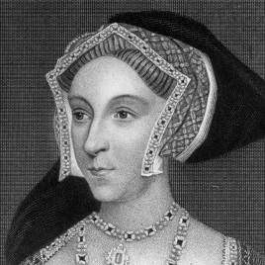

Anne of Cleves: 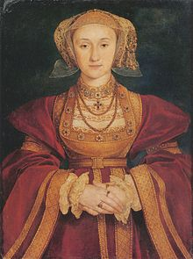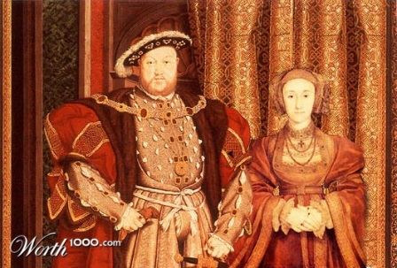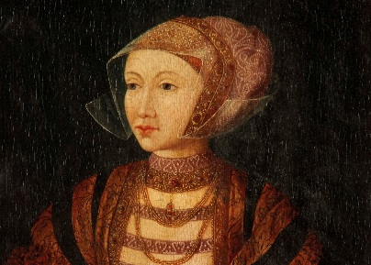

: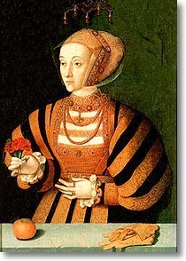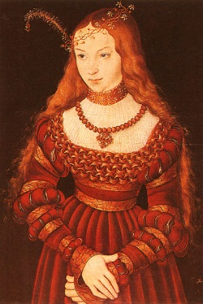

Katherine Howard: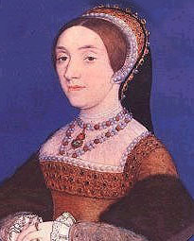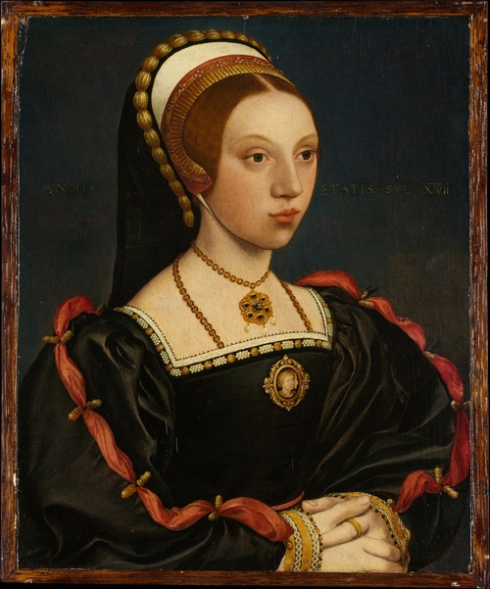

Katherine Parr:

References

(December 7, 2016). Retrieved from https://www.youtube.com/watch?v=tXWrw2CNZyg

Catherine of Aragon. (n.d.) retrieved from
http://www.biography.com/people/catherine-of-aragon-38666

Eakins, L. (2016). Katherine Parr. Retrieved from
http://tudorhistory.org/parr/

Eakins, L. (2016). Kathryn Howard. Retrieved from
http://tudorhistory.org/howard/

Hanson, M. (February 6, 2015) Anne Boleyn Facts & Biography Of Information. Retrieved from
https://englishhistory.net/tudor/monarchs/anne-boleyn/

Hanson, M. (2015). Anne of Cleves: Facts, Information, Biography, and Portraits. Retrieved from
https://englishhistory.net/tudor/monarchs/anne-of-cleves/

Hanson, M. (2015). Catherine Howard: facts, biography, portraits, and information. Retrieved from
https://englishhistory.net/tudor/monarchs/catherine-howard/

Hanson, M. (February 4, 2015). Katharine / Katherine / Catherine of Aragon. Retrieved from
https://englishhistory.net/tudor/monarchs/catherine-of-aragon/

Henry VIII. (2017, April 28). Retrieved from
http://www.biography.com/people/henry-viii-9335322

Palaces, H. R. (n.d.). All about Henry's children. Retrieved from
http://www.hrp.org.uk/palace-kids/discover/all-about-henrys-children/#gs.b3AgQyY

Schmidt, L. B. (2013, February 19). The Times of the Tudors. Retrieved from
http://timesoftudors.blogspot.com/2013/02/the-ideal-beauty.html

